i

**CUSTOMER ANALYTICS SYSTEM**

**ABSTRACT**

We live in a world where large and vast amount of data is collected daily.

Analysing such data is an important need. In the modern era of innovation, where there is a large competition to be better then everyone, the business strategy needs to be according to the modern conditions.

The business done today runs on the basis of innovative ideas as there are large number of potential customers who are confounded to what to buy and what not to buy.

The companies doing the business are also not able to diagnose the target potential customers. This is where the machine learning comes into picture, the various algorithms are applied to identify the hidden patterns in the data for better decision making.

The concept of which customer analytics to target is done using the customer analytics process using the clustering technique.

In this paper, the clustering algorithm used is K-means algorithm which is the partitioning algorithm, to segment the customers according to the similar characteristics. To determine the optimal clusters, elbow method is used.

ii

**TABLE OF CONTENTS**

**CHAPTER TITLE PAGE NO**

**NO.**

**ABSTRACT i**

**LIST OF TABLES iv**

**LIST OF FIGURES v**

1. **INTRODUCTION 1**

1.1 OVERVIEW OF THE PROJECT 1

**2. SYSTEM ANALYSIS**

2.1 EXISTING SYSTEM

2.2 PROPOSED SYSTEM

2.3 FEASIBILITY STUDY

2.4 PROBLEM ANALYSIS

2.4.1 Problem Description

2.5 DATA FLOW DIAGRAM

2.6 SYSTEM SPECIFICATION

2.6.1 Hardware Requirements

2.6.2 Software Requirements

2.6.3 Software Description

iii

**3. SYSTEM DESIGN**

3.1 INPUT DESIGN

3.2 DATABASE DESIGN

3.3 MODULE DESCRIPTION

3.4 OUTPUT DESCRIPTION

**4. SYSTEM TESTING**

4.1 UNIT TESTING

4.2 INTEGRATION TESTING

4.3 VALIDATION TESTING

**5. SYSTEM IMPLEMENTATION**

**6. CONCLUSION AND FUTURE**

**ENHANCEMENTS**

6.1 CONCLUSION

6.2 FUTURE ENHANCEMENTS

**APPENDICES**

APPENDIX 1 : SAMPLE CODE

APPENDIX 2 : SCREENSHOTS

**REFERENCES**

iv

**LIST OF TABLES**

**TABLE NO. TABLE NAME PAGE NO**

1. Login Table
2. Signup Table

**DATASET NAME**

1. Dataset for Details Module
2. Dataset for Files Module

v

**LIST OF FIGURES**

**FIGURE NO FIGURE NAME PAGE NO**

1. Context Diagram
2. Level - 1 DFD
3. Level - 2 DFD for Login Page
4. Level - 2 DFD for Signup Page
5. Level - 2 DFD for Demographic Data
6. Level - 2 DFD for Behavioural Data

A1. Home Page

A2. Login Page

A3. Signup Page

A4. User Services Page

A5. Analytics - Files Page

A6. Analytics - Files Results Page

A7. Analytics - Details Page

A8. Analytics - Details Results Page

1

**CHAPTER - 1**

**INTRODUCTION**

* 1. **OVERVIEW OF THE PRODUCT**

This project is mainly developed for small scale businessman who cannot be able to hire a software developer to develop this app for their specific purposes. The sellers can perform their analysis on the web page according to the certain guidelines we provided.

The sellers (or) businessman can perform the analytics based on the details of the single customer (or) a dataset containing the necessary details of the multiple customers using our website of the project “CUSTOMER ANALYTICS SYSTEM”.

The sellers (or) businessman needs to have a account on our website to use our services. Now, we provide free access to all of our services.

This project will help the sellers (or) businessman by providing better results for the data they provide for the analysis of the customers.

By using the “Analytics using dataset” service, the sellers (or) businessman will get the result in the form of cluster representation but it will not provide better information about the dataset. So, a table representation of the clusters will be provided for them. As this method will help them to target the customers that are analyzed by the project.

2

**CHAPTER - 2**

**SYSTEM ANALYSIS**

**2.1 EXISTING SYSTEM**

* The current system for performing customer segmentation process is limited to a company for their own purposes.
* These systems will support only their hardware for the operations to be done.
* So , small business will not be able to acquire these systems to improve their business as of the cost for the software.

**DISADVANTAGES**

* Analytics increases costs. Cost of production rises due to shorter production runs and product variations.
* Larger inventory has to be maintained by both the manufacturer and the distributors.
* Promotion and distribution expenditures increase when separate program are used for different market segments.
* When characteristics of a market segment change, investment made already might become useless.

3

**2.2 PROPOSED SYSTEM**

* This project is designed to work as the web server (or) the website to support small business peoples to improve their business.
* There is no hardware specifications needed for using this software.
* So, cost is also reduced compared to the application software.

**ADVANTAGES OF PROPOSED SYSTEM**

* The marketer can spot and compare marketing opportunities.
* With the help of knowledge about different segments , the marketer can better allocate the total marketing budget.
* The marketer can modify his product/service and marketing appeals to suit the target segment.
* Segmentation facilitates setting up of realistic selling targets and priorities.
* Management can identify new profitable segments which deserve special attention.

**2.3 FEASIBILITY STUDY**

The feasibility study is intended to be a preliminary review of the facts to see if it is worthy of proceeding to the analysis phase. From the systems analyst perspective, the feasibility analysis is the primary tool for recommending whether to proceed to the next phase or to discontinue the project. Three considerations involved in feasibility analysis are

• Technical Feasibility

• Operational Feasibility

• Economic Feasibility

4

**2.3.1 Technical Feasibility**

A large part of determining resources has to do with assessing technical feasibility. It considers the technical requirements of the proposed project. The technical requirements are then compared to the technical capability of the organization. The systems project is considered technically feasible if the internal technical capability is sufficient to support the project requirements.

**2.3.2 Operational Feasibility**

Operational Feasibility is dependent on human resources available for the project and involves projecting whether the system will be used if it is developed and implemented.

Operational Feasibility is a measure of how well a proposed system solves the problems and takes advantage of the opportunities identified during scope definition and how it satisfies the requirements identified in the requirements analysis phase of system development.

**2.3.3 Economical Feasibility**

Economic analysis could also be referred to as cost / benefit analysis. It is the most frequently used method for evaluating the effectiveness of a new system. In economic analysis the procedure is to determine the benefits and savings that are expected from a candidate system and compare them with costs. If benefits outweigh costs, then the decision is made to design and implement the system. An entrepreneur must accurately weigh the cost versus benefits before taking an action.

5

The concerned business must be able to see the value of the investment it is pondering before committing to an entire system study. If the expected benefits equal or exceed costs, the system can be judged to be economically feasible.

The economic feasibility will review the expected costs to see if they are in-line with the projected budget or if the project has an acceptable return or investment. At this point, the projected costs will only be a rough estimate. The required timeframe would need to be set by the organization. The extra costs are not required to determine this feasibility.

**2.4 PROBLEM ANALYSIS**

The current system for performing customer segmentation process is limited to a company for their own purposes. These systems will support only their hardware for the operations to be done. So , small business will not be able to acquire these systems to improve their business as of the cost for the software. It comes to know that one of the main disadvantages of previous system.

**2.4.1 Problem Description**

In general, this project is developed mainly as a software application to use it for their specific purposes and the results are given better for the analysis. So, there is a need for a proposed system to rectify the drawbacks of this previous system and the required system is developed.

6

**2.5 DATA FLOW DIAGRAM**

Data flow diagrams are used to graphically represent the flow of data in a business information system. DFD describes the processes that are involved in a system to transfer data from the input to the file storage and reports generation.

DFD graphically representing the functions, or processes, which capture, manipulate, store, and distribute data between a system and its environment and between components of a system. The visual representation makes it a good communication tool between User and System designer. Structure of DFD allows starting from a broad overview and expand it to a hierarchy of detailed diagrams.

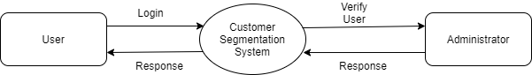

**Figure 2.1 Context Diagram**

**7**

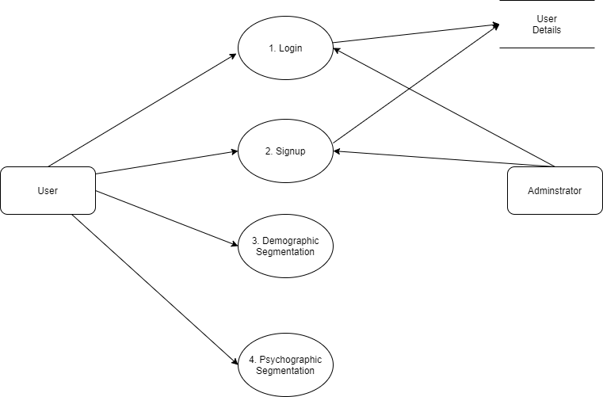

**Figure 2.2 Level - 1 DFD**

8

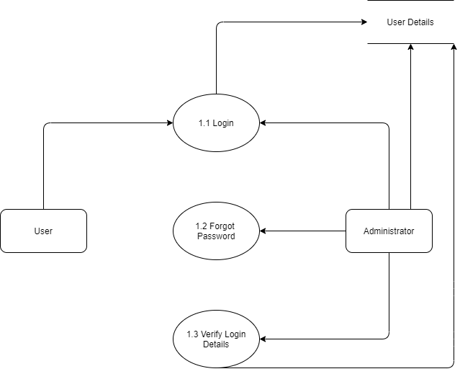

**Figure 2.3 Level - 2 DFD for Login Page**

9

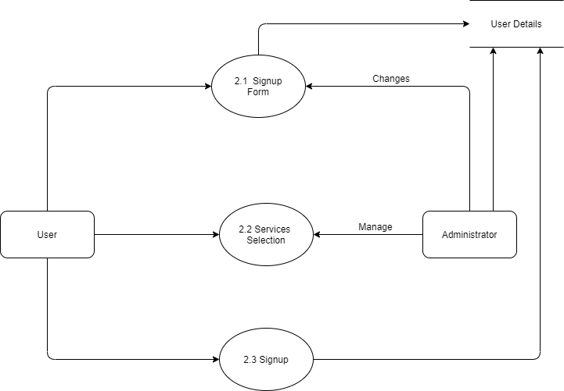

**Figure 2.4 Level - 2 DFD for Signup Page**

10

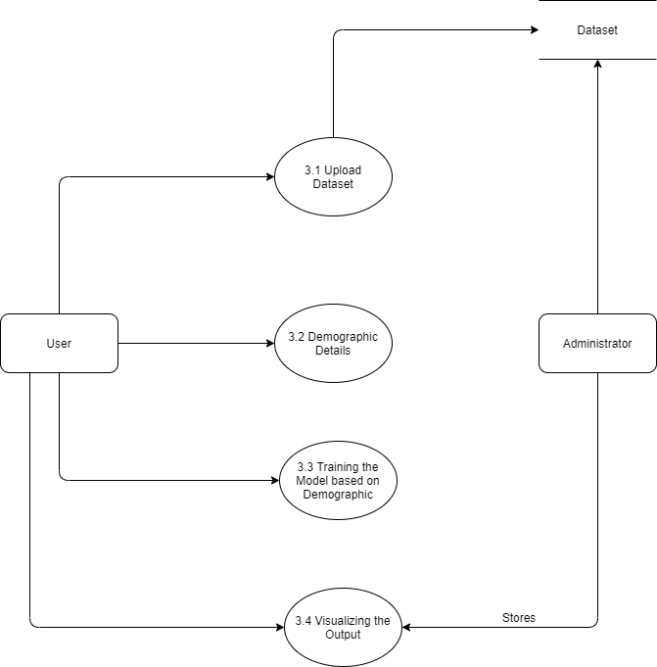

**Figure 2.5 Level - 2 DFD for Demographic Analytics**

11

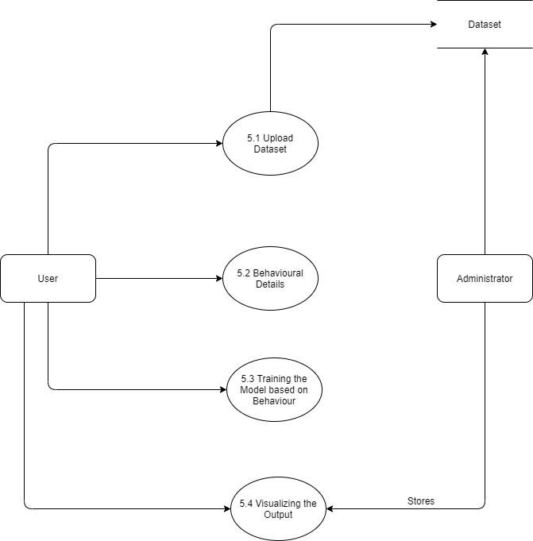

**Figure 2.6 Level - 2 DFD for Behaviour Analytics**

12

**2.6 SYSTEM SPECIFICATIONS**

**2.6.1 HARDWARE SPECIFICATIONS**

This section gives the details and specification of the hardware on which the system is expected to work.

* + - Processor : Intel Core i3 (6th Generation) or higher.
    - RAM : 4GB RAM DDR4 (or) higher.
    - VRAM : 256MB
    - Good Internet Connectivity Required.

**2.6.2 SOFTWARE SPECIFICATIONS**

This section gives the details of the software that are used for the development.

* Operating System : Windows 10
* Backend Languages : Python, Django
* Frontend Languages : HTML, CSS, JavaScript and Bootstrap
* Database : MySQL

13

**2.6.3 SOFTWARE DESCRIPTION**

**FRONT - END**

* **HTML(Hyper Text Markup Language)**

**Hyper Text Markup Language** (**HTML**) is a markup language for creating a webpage. Webpages are usually viewed in a web browser. They can include writing, links, pictures, and even sound and video. HTML is used to mark and describe each of these kinds of content so the web browser can display them correctly. HTML also adds meta information to a webpage. Meta information is usually not shown by web browsers and is data about the web page, e.g., the name of the person who created the page. Cascading Style Sheets (CSS) is used to style HTML elements while JavaScript is used for website behaviour and also changing the HTML and CSS.

The role of HTML is to inform a web browser about how the content contained within an HTML file is structured. Commonly used HTML tags include <H1>, which describes a top-level heading; <H2>, which describes a second-level heading; <p> to describe a paragraph; <table>, which describes tabular data; and <ol>, which describes an ordered list of information.

* **CSS (Cascading Style Sheets)**

Cascading Style Sheet is a style sheet language used for describing the presentation of a document written in a markup language Although most often used to set the visual style of web page and user interfaces written in HTML and XHTML, the language can be applied to any XML document, including plain

14

XML, SVG and XUL, and is applicable to rendering in speech, or on other media. Along with HTML and JavaScript, CSS is a cornerstone technology used by most websites to create visually engaging webpages, user interfaces for web applications, and user interfaces for many mobile applications.

* **JS (JavaScript)**

JavaScript  often abbreviated as **JS**, is a programming language that conforms to the ECMAScript specification.

 JavaScript is high-level, often just-in-time compiled, and multi-paradigm. It has curly-bracket syntax, dynamic typing, prototype-based, object-orientation, and first-class functions.

Alongside HTML and CSS, JavaScript is one of the core technologies of the World Wide Web.Over 97% of websites use it client-side for web page behavior, often incorporating third-party libraries. All major web browsers have a dedicated JavaScript engine to execute the code on the user's device.

* **Bootstrap**

Bootstrap is a free and open-source, front-end framework designing websites and web applications. It contains HTML- and CSS-based design templates for typography, forms, buttons, navigation and other interface components, as well as optional JavaScript extensions. Unlike many web frameworks, it concerns itself with front-end development only. As of Bootstrap 4, Sass is used instead of less for the style sheets. Each Bootstrap

15

component consists of an HTML structure, CSS declarations, and in some cases accompanying JavaScript code.

**BACK - END**

* **PYTHON**

**Python** is an interpreted high-level general-purpose programming language. Python's design philosophy emphasizes code readability with its notable use of significant indentation. Its language constructs as well as its object-oriented approach aim to help programmers write clear, logical code for small and large-scale projects.

Python is dynamically-typed and garbage-collected. It supports multiple programming paradigms, including structured (particularly, procedural), object-oriented and functional programming. Python is often described as a "batteries included" language due to its comprehensive standard library.

* **DJANGO**

Django is a high-level Python Web framework that encourages rapid development and clean pragmatic design. A Web framework is a set of components that provide a standard way to develop websites fast and easily. Django’s primary goal is to ease the creation of complex database-driven websites.

In a traditional data-driven website, a web application waits for HTTP requests from the web browser (or another client). When a request is received the application works out what is needed based on the URL and possibly information in POST data or GET data.

16

Depending on what is required it may then read or write information from a database or perform other tasks required to satisfy the request. The application will then return a response to the web browser, often dynamically creating an HTML page for the browser to display by inserting the retrieved data into placeholders in an HTML template.

Django web applications typically group the code that handles each of these steps into separate files:

• **URLs:** While it is possible to process requests from every single URL via a single function, it is much more maintainable to write a separate view function to handle each resource. A URL mapper is used to redirect HTTP requests to the appropriate view based on the request URL. The URL mapper can also match patterns of strings or digits that appear in a URL and pass these to a view function as data.

• **View:** A view is a request handler function, which receives HTTP requests and returns HTTP responses. Views access the data needed to satisfy requests via models, and delegate the formatting of the response to templates.

• **Models:** Models are Python objects that define the structure of an application's data, and provide mechanisms to manage (add, modify, delete) and query records in the database.

• **Templates:** A template is a text file defining the structure or layout of a file (such as an HTML page), with placeholders used to represent actual content. A view can dynamically create an

17

HTML page using an HTML template, populating it with data from a model. A template can be used to define the structure of any type of file, it does not have to be HTML.

**DATABASE**

* **MYSQL**

MySQL is free and open-source software under the terms of the GNU General Public License, and is also available under a variety of proprietary licenses. MySQL was owned and sponsored by the Swedish company MySQL AB, which was bought by Sun Microsystems (now Oracle Corporation). In 2010, when Oracle acquired Sun, Widenius forked the open-source MySQL project to create MariaDB.

MySQL has stand-alone clients that allow users to interact directly with a MySQL database using SQL, but more often MySQL is used with other programs to implement applications that need relational database capability. MySQL is a component of the [LAMP](https://en.wikipedia.org/wiki/LAMP_(software_bundle)) web application software stack (and others), which is an acronym for Linux, Apache, MySQL, Perl/PHP/Python. MySQL is used by many database-driven web applications, including Drupal, Joomla, phpBB, and WordPress. MySQL is also used by many popular websites, including Facebook, Flickr, MediaWiki, Twitter, and YouTube.

Django attempts to support as many features as possible on all database backends. However, not all database backends are alike, and we have had to make design decisions on which features to support and which assumptions we can make safely.

18

We normally need to edit **settings.py** which is a python module with module level variables representing Django settings.

However, since the configuration uses MySQL by default, and MySQL is included in python, we do not need to install anything else to support our database.

**Features of MySQL:**

* Relational Database Management System(RDBMS)
* Easy to Use
* Secure
* Client / Server Architecture
* Scalable
* Speed
* High Flexibility
* Memory Efficiency
* High Performance

19

**CHAPTER - 3**

**SYSTEM DESIGN**

**3.1 INPUT DESIGN**

In an information system, input is the raw data that is processed to produce output. During the input design, the developers must consider the input devices such as PC, MICR, OMR, etc. Therefore, the quality of system input determines the quality of system output. Well designed input forms and screens have following properties –

• It should serve specific purpose effectively such as storing, recording, and retrieving the information.

• It ensures proper completion with accuracy.

• It should be easy to fill and straightforward.

• It should focus on user’s attention, consistency, and simplicity.

**Objectives for Input Design**

The objectives of input design are −

• To design data entry and input procedures

• To reduce input volume

• To design input data records, data entry screens, user interface screens, etc.

• To use validation checks and develop effective input controls.

20

**Login Form**

The Login form is used to login to the system to access our services and manage their account details of the existing user.

It contains the fields such as E – Mail and Password and an link to access the Signup Page.

**Signup Form**

The Signup Form is used to allow the user to create a new account for them to use our services and manage their account details.

It contains the fields such as First Name, Last Name, Date Of Birth, Age, E – Mail, Password and Confirm Password and an link to access the Login Page.

**Services Form**

The Services Form is used to display the user with the available services we offer for them such as Analytics using Dataset and Analytics using Details.

Analytics using Dataset service contains a field to upload their dataset with the instructions we provided. After uploading the dataset, a visualization of the clusters will be displayed along with a button to display the visualization in the table format. The table will display the customers who have the possibility of buying the product.

Analytics using Details service contains a form to get the details of the customers such as First Name, Last Name, Age, Annual Income and Spending Score. It contains the fields such as First Name, Last Name, Age, Annual Income and Spending Score. After submitting the details, it will display the details of the customers along with the possibility of buying the product.

21

**3.2 DATABASE DESIGN**

Database design is the organization of data according to a database model. The designer determines what data must be stored and how the data elements interrelate. With this information, they can begin to fit the data to the database model. Database management system manages the data accordingly. The main objectives of designing a database are,

• Data Integration

• Data Integrity

• Data Independence

**Data integration**

Data integration refers to the technical and business processes used to combine data from multiple sources to provide a unified, single view of the data.

**Data integrity**

Data integrity is the overall completeness, accuracy and consistency of data. This can be indicated by the absence of alteration between two instances or between two updates of a data record, meaning data is intact and unchanged.

22 **Data independence**

The table needed for the application is identified and were designed to meet the requirement specification of the system. The specification of each and every column is stated clearly for every functional part in the application.

**3.2.1 TABLE DESIGN**

**Table 3.1.1 Login Table**

|  |  |  |
| --- | --- | --- |
| **FIELD NAME** | **DATA TYPE** | **KEY CONSTRAINT** |
| First Name | VARCHAR(30) | NOT NULL |
| Last Name | VARCHAR(30) | NOT NULL |
| E Mail | VARCHAR(50) | NOT NULL |
| Password | VARCHAR(30) | NOT NULL |

**Table 3.1.2 Signup Table**

|  |  |  |
| --- | --- | --- |
| **FIELD NAME** | **DATA TYPE** | **KEY CONSTRAINT** |
| First Name | VARCHAR(30) | NOT NULL |
| Last Name | VARCHAR(30) | NOT NULL |
| DOB | VARCHAR(20) | NOT NULL |
| E Mail | VARCHAR(50) | NOT NULL |
| Mobile No | VARCHAR(20) | NOT NULL |
| Password | VARCHAR(30) | NOT NULL |
| Confirmpass | VARCHAR(30) | NOT NULL |

23

**Table 3.2.1 Details Table**

**Dataset for Analytics using Details Module**

|  |  |  |
| --- | --- | --- |
| **FIELD NAME** | **DATA TYPE** | **KEY CONSTRAINT** |
| Customer ID | INT(5) | NOT NULL |
| Gender | VARCHAR(10) | NOT NULL |
| Age | INT(5) | NOT NULL |
| Annual Income(k$) | INT(5) | NOT NULL |
| Spending Score(1 – 100) | INT(5) | NOT NULL |
| Purchased | INT(5) | NOT NULL |

**Table 3.2.2 Files Table**

**Dataset for Analytics using Dataset Module**

|  |  |  |
| --- | --- | --- |
| **FIELD NAME** | **DATA TYPE** | **KEY CONSTRAINT** |
| Customer ID | INT(5) | NOT NULL |
| Customer Name | VARCHAR(30) | NOT NULL |
| Gender | VARCHAR(10) | NOT NULL |
| Age | INT(5) | NOT NULL |
| Mobile Number | INT(15) | NOT NULL |
| Annual Income(k$) | INT(5) | NOT NULL |
| Spending Score(1 – 100) | INT(5) | NOT NULL |

24

**3.3 MODULE DESCRIPTION**

The main modules exist in the “CUSTOMER ANALYTICS SYSTEM” project are listed below,

* Home Page
* Login Page
* Signup Page
* Services Page
* Analytics Using Details Page
* Analytics Using Details Results Page
* Analytics Using Dataset Page
* Analytics Using Dataset Results Page
* **Home Page**

The Home Page of the project contains the information about our project, a Login button to access the Login Page of our project, a Signup button to access the Signup Page of the project and a About section which describes about our work in the project.

* **Login Page**

The Login Page of the project allows a user who are created a account already with us to access our services we provide by signing in to their account. The details needed to perform Login in the page are E – Mail and Password.

25

* **Signup Page**

The Signup Page of the project allows people to create a account with us and use our services to satisfy their needs. The details needed to perform Signup operation in the page are First Name, Last Name, DOB, Age, E Mail, Mobile No, Password, Confirmpass.

* **Services Page**

The Services Page of the project allows logged in users only to use our services. A Logout button to provided when users decide to end their session. The services provided here are Analytics using Details Provided and Analytics using Dataset. These services are having the hyperlinks which will the users to the necessary pages to perform their operations and analyze the results.

* **Analytics using Details Page**

The Analytics using Details Page of the project allows the user to analyze the details of the single customer. The fields provided to get the analyzes done are First Name, Last Name, Age, Annual Income(k$) and Spending Score(1 – 100).

* **Analytics using Details Results Page**

The Analytics using Details Results Page of the project displays the user with the details of the customers they provided. And the result of the analysis such as the possibility of buying the product.

26

* **Analytics using Dataset Page**

The Analytics using Dataset Page of the project allow the user to upload their dataset with the specified instructions by us. This will analyze the dataset with the ML model and display the visualization of the clusters in the results page.

* **Analytics using Dataset Results Page**

The Analytics using Dataset Results Page of the project displays the user with the visualization of the cluster predicted by the ML model. As the Cluster visualization will be not understandable by the user so a additional table representation is provided to display the customer details in the table format. So they can clear understanding about the predicted results.

**3.4 OUTPUT DESCRIPTION**

A design output is a drawing or specification or manufacturing instruction. Design outputs describe all the components, parts, and pieces that go into your medical device. Design outputs established during product development become the basis of the device master record (DMR) when in production. All output should have a purpose. During the information requirements determination phase of analysis, the systems analyst finds out what user and organizational purposes exist. Output is then designed based on those purposes.

27

**CHAPTER - 4**

**SYSTEM TESTING**

System testing is testing conducted on a complete integrated system to evaluate the system's compliance with its specified requirements. System testing is performed on the entire system in the context of either functional requirement specifications (FRS) or system requirement specification (SRS), or both. System testing tests not only the design, but also the behaviour and even the believed expectations of the customer. It is also intended to test up to and beyond the bounds defined in the software or hardware requirements specification(s).This project has undergone the following testing procedures to ensure its correctness.

• Unit Testing

• Integration Testing

• Validation Testing

**4.1 UNIT TESTING**

Unit Testing is a software testing technique by means of which individual units of software i.e. group of computer program modules, usage procedures and operating procedures are tested to determine whether they are suitable for use or not. It is a testing method using which every independent modules are tested to determine if there are any issue by the developer himself. It is correlated with functional correctness of the independent modules.

In SDLC or V Model, Unit testing is first level of testing done before integration testing. Unit testing is such type of testing technique that is usually performed by the developers. Although due to reluctance of developers to tests, quality assurance engineers also do unit testing.

28 **4.2 INTEGRATION TESTING**

Integration testing is the process of testing the interface between two software units or module. It’s focus on determining the correctness of the interface. The purpose of the integration testing is to expose faults in the interaction between integrated units. Once all the modules have been unit tested, integration testing is performed.

**4.3 VALIDATION TESTING**

Validation testing is the process of ensuring if the tested and developed software satisfies the client /user needs. The business requirement logic or scenarios have to be tested in detail. .As a tester, you need to evaluate if the test execution results comply with that mentioned in the requirements document.

When software is tested, the motive is to check the quality regarding the found defects and bugs. When defects and bugs are detected, developers fix them. After that, the software is checked again to make sure no bugs are left. In that way, the software product’s quality scales up.

29

**CHAPTER - 5**

**SYSTEM IMPLEMENTATION**

System implementation is the process of: defining how the information system should be built, ensuring that the information system is operational and used, ensuring that the information system meets quality standard. The aim of the trail run was to identify any malfunction of the system. After the management of the system was approved the system implemented in the concern, initially the system was run parallel with existing manual system.

**CODING**

Coding is the process, whereby the physical design specifications turned into working computer code. In this application Python Django is used for coding. This is a stable framework and has a large user community. The controllers, models and views are coded and designed as such the customer experience a smooth working.

**TESTING**

Once the coding process begins, testing for each program module is done in parallel. In this application all the modules are tested in parallel to the development of the each module which helps to make the system error free.

**INSTALLATION**

Installation is the process during which the current system is replaced by the new system. This includes conversion of existing data, software, and documentation and work procedures to those consistent with the new system.

30 **DOCUMENTATION**

The necessity of the documentation for the application is negative. The system gives a smooth, efficient and convenient experience to purchase the jewellery. When the customer enters into the application, he can choose any needed operation easily as it will be understandable for all users.

31

**CHAPTER - 6**

**CONCLUSION AND FUTURE ENHANCEMENTS**

**6.1 CONCLUSION**

This project “CUSTOMER ANALYTICS SYSTEM” is completed successfully in more reliable and user friendly manner. This system helps the sellers (or) businessman by providing an efficient and integrated service of performing analytics on their customers data. There is no risk while using this application. All the details of the users and their login details are stored securely in a database. The system is tested with various sample inputs and is made to provide an error free and smooth experience to the users.

This system helps the user to effectively analyze the customer details and target those customers to improve their business. This system can be used anywhere at any time thus reducing time, cost and effort factors.

**6.2 FUTURE ENHANCEMENTS**

Multilingual support can be provided so that it can be understandable by the person of any language and this application can run through the mobile phone also.

32

**APPENDICES**

**APPENDIX 1**

**SAMPLE CODE**

1. **HomePage.html**

<!DOCTYPE html>

<html lang="en">

<head>

<meta charset="utf-8">

<meta content="width=device-width, initial-scale=1.0" name="viewport">

<title>Welcome to DataXAnalytics</title>

<meta content="" name="description">

<meta content="" name="keywords">

<!-- Google Fonts -->

<link href="https://fonts.googleapis.com/css?family=Open+Sans:300,300i,400,400i,600,600i,700,700i|Raleway:300,300i,400,400i,500,500i,600,600i,700,700i|Poppins:300,300i,400,400i,500,500i,600,600i,700,700i" rel="stylesheet">

<!-- Vendor CSS Files -->

<link href="/static/vendor/animate.css/animate.min.css" rel="stylesheet">

<link href="/static/vendor/aos/aos.css" rel="stylesheet">

<link href="/static/vendor/bootstrap/css/bootstrap.min.css" rel="stylesheet">

<link href="/static/vendor/bootstrap-icons/bootstrap-icons.css" rel="stylesheet">

<link href="/static/vendor/boxicons/css/boxicons.min.css" rel="stylesheet">

<link href="/static/vendor/glightbox/css/glightbox.min.css" rel="stylesheet">

<link href="/static/vendor/remixicon/remixicon.css" rel="stylesheet">

<link href="/static/vendor/swiper/swiper-bundle.min.css" rel="stylesheet">

<!-- Template Main CSS File -->

<link href="/static/css/style.css" rel="stylesheet">

<!-- =======================================================

* Template Name: Selecao - v4.0.1

* Template URL: https://bootstrapmade.com/selecao-bootstrap-template/

* Author: BootstrapMade.com

* License: https://bootstrapmade.com/license/

======================================================== -->

</head>

<body>

33

<!-- ======= Header ======= -->

<header id="header" class="fixed-top d-flex align-items-center header-transparent ">

<div class="container d-flex align-items-center justify-content-between">

<div class="logo">

<h1><a href="{% url 'homeview' %}">DataXAnalytics</a></h1>

</div>

<nav id="navbar" class="navbar">

<ul>

<li><a class="nav-link scrollto active" href="#hero">Home</a></li>

<li><a class="nav-link scrollto" href="#about">About</a></li>

<li><a class="nav-link scrollto" href="{% url 'loginview' %}">Login</a></li>

<li><a class="nav-link scrollto" href="{% url 'signupview' %}">Sign Up</a></li>

</ul>

<i class="bi bi-list mobile-nav-toggle"></i>

</nav><!-- .navbar -->

</div>

</header><!-- End Header -->

<!-- ======= Hero Section ======= -->

<section id="hero" class="d-flex flex-column justify-content-end align-items-center">

<div id="heroCarousel" data-bs-interval="5000" class="container carousel carousel-fade" data-bs-ride="carousel">

<!-- Slide 1 -->

<div class="carousel-item active">

<div class="carousel-container">

<h2 class="animate__animated animate__fadeInDown">Welcome to <span>DataXAnalytics</span></h2>

<p class="animate__animated fanimate__adeInUp">At DataXAnalytics, we help our customers to perform Analysis process in the ease by the uploaded dataset or by providing the necessary details.</p>

<a href="#about" class="btn-get-started animate__animated animate__fadeInUp scrollto">Read More</a>

</div>

</div>

</div>

<svg class="hero-waves" xmlns="http://www.w3.org/2000/svg" xmlns:xlink="http://www.w3.org/1999/xlink" viewBox="0 24 150 28 " preserveAspectRatio="none">

<defs>

<path id="wave-path" d="M-160 44c30 0 58-18 88-18s 58 18 88 18 58-18 88-18 58 18 88 18 v44h-352z"></path>

</defs>

<g class="wave1">

<use xlink:href="#wave-path" x="50" y="3" fill="rgba(255,255,255, .1)"></use>

34

</g>

<g class="wave2">

<use xlink:href="#wave-path" x="50" y="0" fill="rgba(255,255,255, .2)"></use>

</g>

<g class="wave3">

<use xlink:href="#wave-path" x="50" y="9" fill="#fff"></use>

</g>

</svg>

</section><!-- End Hero -->

<main id="main">

<!-- ======= About Section ======= -->

<section id="about" class="about">

<div class="container">

<div class="section-title" data-aos="zoom-out">

<h2>About</h2>

<p>Who we are</p>

</div>

<div class="row content" data-aos="fade-up">

<div class="col-lg-6">

<p>

We are at the team of DataXAnalytics, providing our users to get clear insights about their buisness.

Providing ideas to improve thier buisness.

</p>

<ul>

<li><i class="ri-check-double-line"></i>Helping our customers to improve their buisness</li>

<li><i class="ri-check-double-line"></i>To get clear visulaization and ideas to improve their business strategies</li>

</ul>

</div>

</div>

</div>

</section><!-- End About Section -->

</main><!-- End #main -->

<!-- ======= Footer ======= -->

<footer id="footer">

<div class="container">

<h3>DataXAnalytics</h3>

<div class="social-links">

<a href="#" class="twitter"><i class="bx bxl-twitter"></i></a>

<a href="#" class="linkedin"><i class="bx bxl-linkedin"></i></a>

35

</div>

</div>

</footer><!-- End Footer -->

<a href="#" class="back-to-top d-flex align-items-center justify-content-center"><i class="bi bi-arrow-up-short"></i></a>

<!-- Vendor JS Files -->

<script src="/static/vendor/aos/aos.js"></script>

<script src="/static/vendor/bootstrap/js/bootstrap.bundle.min.js"></script>

<script src="/static/vendor/glightbox/js/glightbox.min.js"></script>

<script src="/static/vendor/isotope-layout/isotope.pkgd.min.js"></script>

<script src="/static/vendor/php-email-form/validate.js"></script>

<script src="/static/vendor/swiper/swiper-bundle.min.js"></script>

<!-- Template Main JS File -->

<script src="/static/js/main.js"></script>

</body>

</html>

1. **Services.html**

<!DOCTYPE html>

<html lang="en">

<head>

<meta charset="utf-8">

<meta content="width=device-width, initial-scale=1.0" name="viewport">

<title>Welcome to DataXAnalytics</title>

<meta content="" name="description">

<meta content="" name="keywords">

<!-- Google Fonts -->

<link href="https://fonts.googleapis.com/css?family=Open+Sans:300,300i,400,400i,600,600i,700,700i|Raleway:300,300i,400,400i,500,500i,600,600i,700,700i|Poppins:300,300i,400,400i,500,500i,600,600i,700,700i" rel="stylesheet">

<!-- Vendor CSS Files -->

<link href="/static/vendor/animate.css/animate.min.css" rel="stylesheet">

<link href="/static/vendor/aos/aos.css" rel="stylesheet">

<link href="/static/vendor/bootstrap/css/bootstrap.min.css" rel="stylesheet">

<link href="/static/vendor/bootstrap-icons/bootstrap-icons.css" rel="stylesheet">

<link href="/static/vendor/boxicons/css/boxicons.min.css" rel="stylesheet">

<link href="/static/vendor/glightbox/css/glightbox.min.css" rel="stylesheet">

<link href="/static/vendor/remixicon/remixicon.css" rel="stylesheet">

36

<link href="/static/vendor/swiper/swiper-bundle.min.css" rel="stylesheet">

<!-- Template Main CSS File -->

<link href="/static/css/style.css" rel="stylesheet">

<!-- =======================================================

* Template Name: Selecao - v4.0.1

* Template URL: https://bootstrapmade.com/selecao-bootstrap-template/

* Author: BootstrapMade.com

* License: https://bootstrapmade.com/license/

======================================================== -->

</head>

<body>

<!-- ======= Header ======= -->

<header id="header" class="fixed-top d-flex align-items-center header-transparent ">

<div class="container d-flex align-items-center justify-content-between">

<div class="logo">

<h1><a href="{% url 'homeview' %}">DataXAnalytics</a></h1>

</div>

<nav id="navbar" class="navbar">

<ul>

<li><a class="nav-link scrollto" href="{% url 'homeview' %}">Logout</a></li>

</ul>

<i class="bi bi-list mobile-nav-toggle"></i>

</nav><!-- .navbar -->

</div>

</header><!-- End Header -->

<!-- ======= Hero Section ======= -->

<section id="hero" class="d-flex flex-column justify-content-end align-items-center">

<div id="heroCarousel" data-bs-interval="5000" class="container carousel carousel-fade" data-bs-ride="carousel">

<!-- Slide 1 -->

<div class="carousel-item active">

<div class="carousel-container">

<h2 class="animate__animated animate__fadeInDown">Welcome to <span>DataXAnalytics</span></h2>

</div>

</div>

</div>

<svg class="hero-waves" xmlns="http://www.w3.org/2000/svg" xmlns:xlink="http://www.w3.org/1999/xlink" viewBox="0 24 150 28 " preserveAspectRatio="none">

<defs>

37

<path id="wave-path" d="M-160 44c30 0 58-18 88-18s 58 18 88 18 58-18 88-18 58 18 88 18 v44h-352z"></path>

</defs>

<g class="wave1">

<use xlink:href="#wave-path" x="50" y="3" fill="rgba(255,255,255, .1)"></use>

</g>

<g class="wave2">

<use xlink:href="#wave-path" x="50" y="0" fill="rgba(255,255,255, .2)"></use>

</g>

<g class="wave3">

<use xlink:href="#wave-path" x="50" y="9" fill="#fff"></use>

</g>

</svg>

</section><!-- End Hero -->

<main id="main">

<!-- ======= Services Section ======= -->

<section id="services" class="services">

<div class="container">

<div class="section-title" data-aos="zoom-out">

<h2>Services</h2>

<p>What we do offer</p>

</div>

<div class="row">

<div class="col-lg-4 col-md-6">

<div class="icon-box" data-aos="zoom-in-left">

<div class="icon"><i class="bi bi-briefcase" style="color: #ff689b;"></i></div>

<h4 class="title"><a href="{% url 'filesview' %}">Customer Analytics using Dataset</a></h4>

</div>

</div>

<div class="col-lg-4 col-md-6 mt-5 mt-md-0">

<div class="icon-box" data-aos="zoom-in-left" data-aos-delay="100">

<div class="icon"><i class="bi bi-book" style="color: #e9bf06;"></i></div>

<h4 class="title"><a href="{% url 'detailsview' %}">Customer Analysis using Details Provided</a></h4>

</div>

</div>

</div>

</div>

</section><!-- End Services Section -->

</main><!-- End #main -->

<!-- ======= Footer ======= -->

38

<footer id="footer">

<div class="container">

<h3>DataXAnalytics</h3>

<div class="social-links">

<a href="#" class="twitter"><i class="bx bxl-twitter"></i></a>

<a href="#" class="linkedin"><i class="bx bxl-linkedin"></i></a>

</div>

</div>

</footer><!-- End Footer -->

<a href="#" class="back-to-top d-flex align-items-center justify-content-center"><i class="bi bi-arrow-up-short"></i></a>

<!-- Vendor JS Files -->

<script src="/static/vendor/aos/aos.js"></script>

<script src="/static/vendor/bootstrap/js/bootstrap.bundle.min.js"></script>

<script src="/static/vendor/glightbox/js/glightbox.min.js"></script>

<script src="/static/vendor/isotope-layout/isotope.pkgd.min.js"></script>

<script src="/static/vendor/php-email-form/validate.js"></script>

<script src="/static/vendor/swiper/swiper-bundle.min.js"></script>

<!-- Template Main JS File -->

<script src="/static/js/main.js"></script>

</body>

</html>

39

**APPENDIX 2**

**SAMPLE SCREENSHOTS**

**Figure A1 - Home Page**

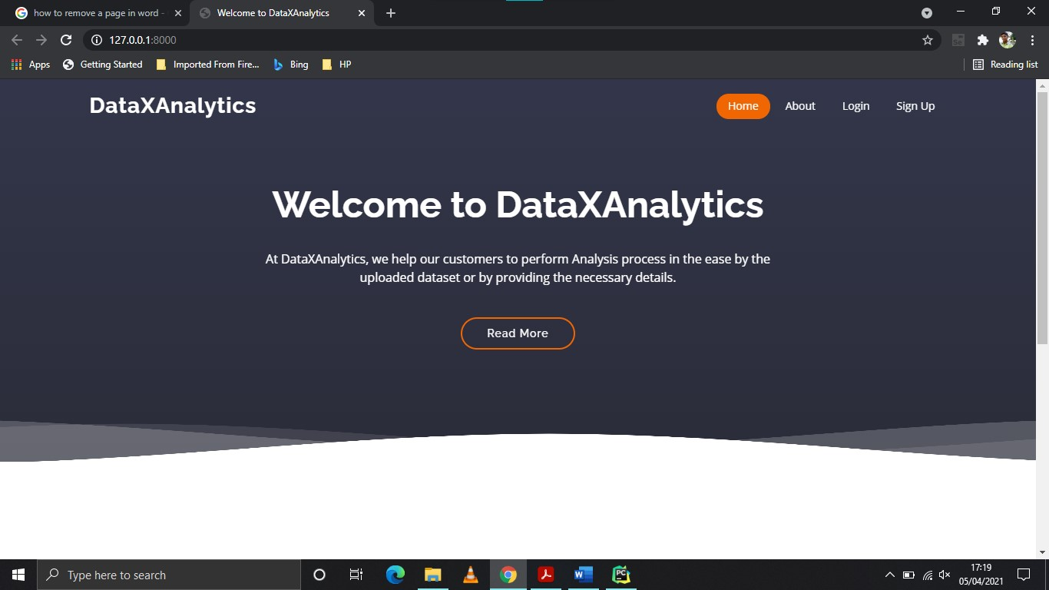

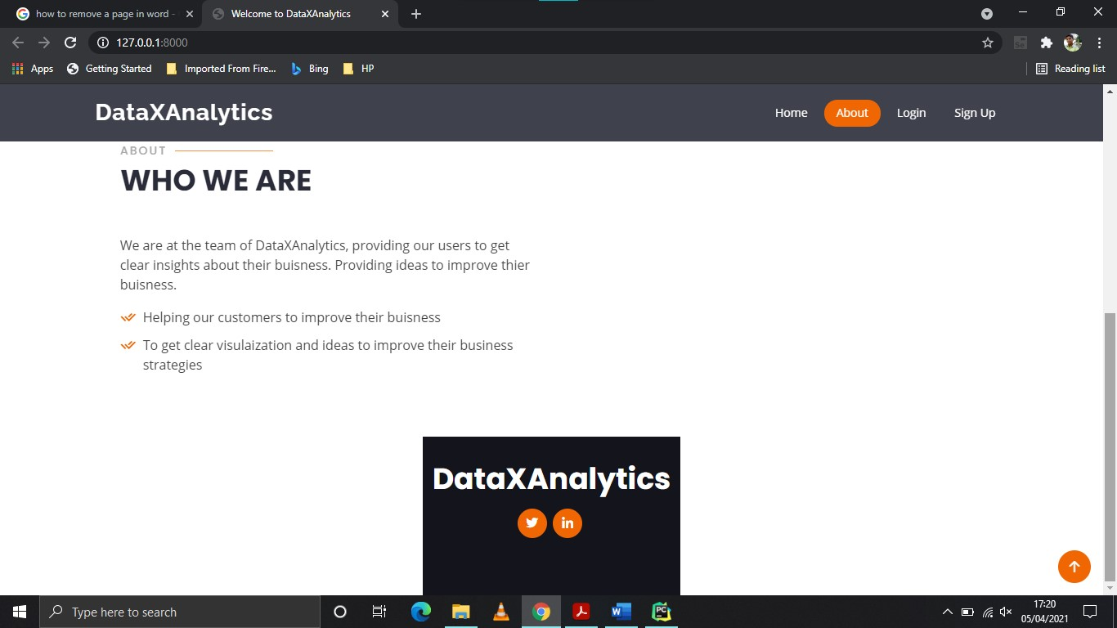

40 **Figure A2 – Login Page**

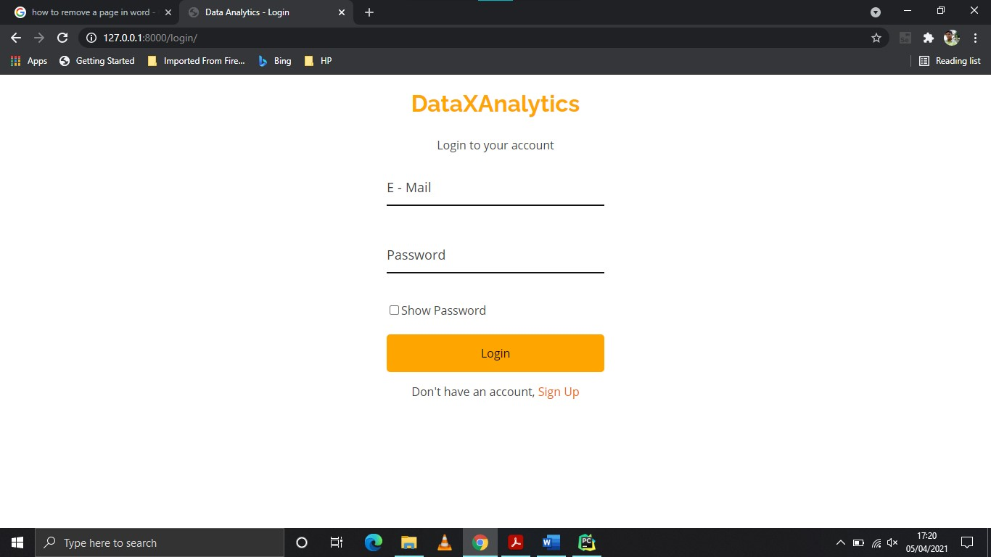

**Figure A3 – Signup Page**

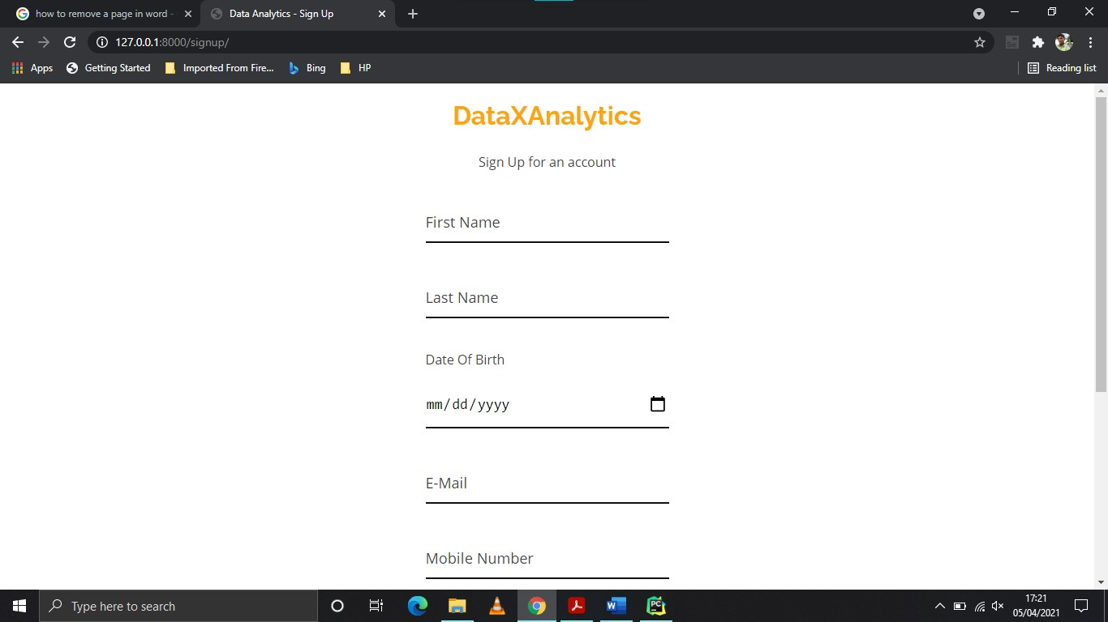

41

**Figure A4 – Services Page**

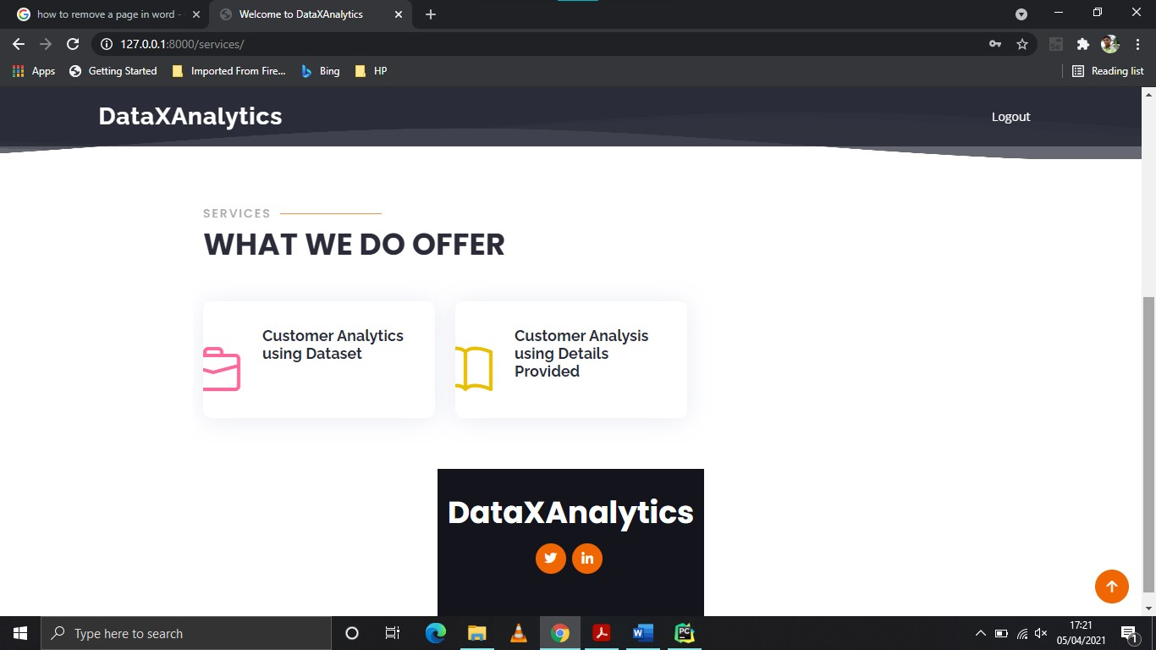

**Figure A5 - Analytics - Files Page**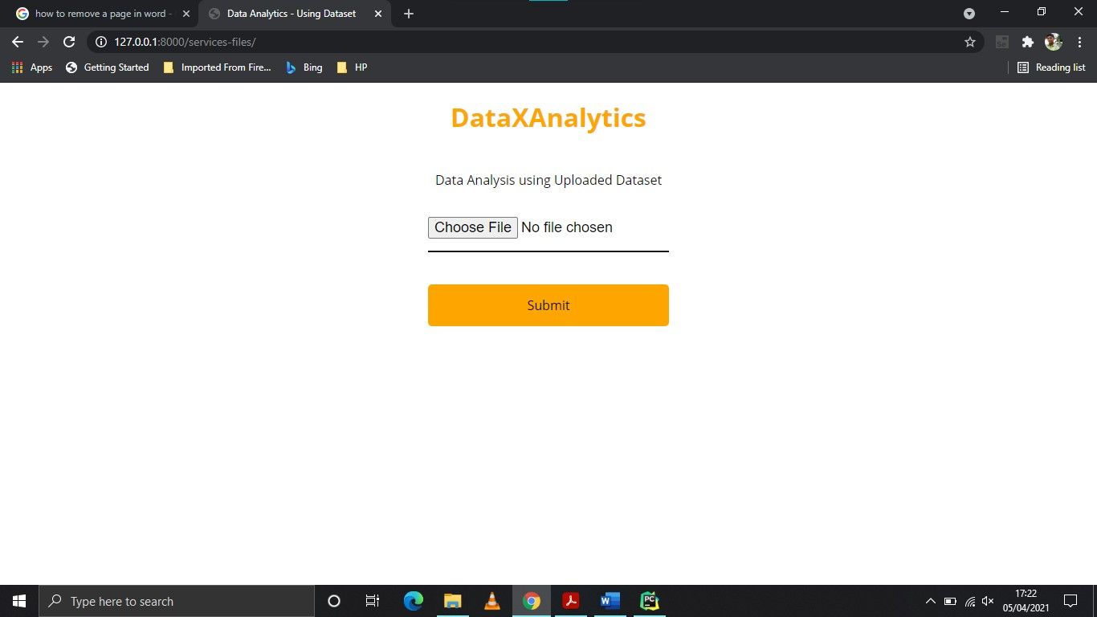

42

**Figure A6 – Analytics - Files Results Page**



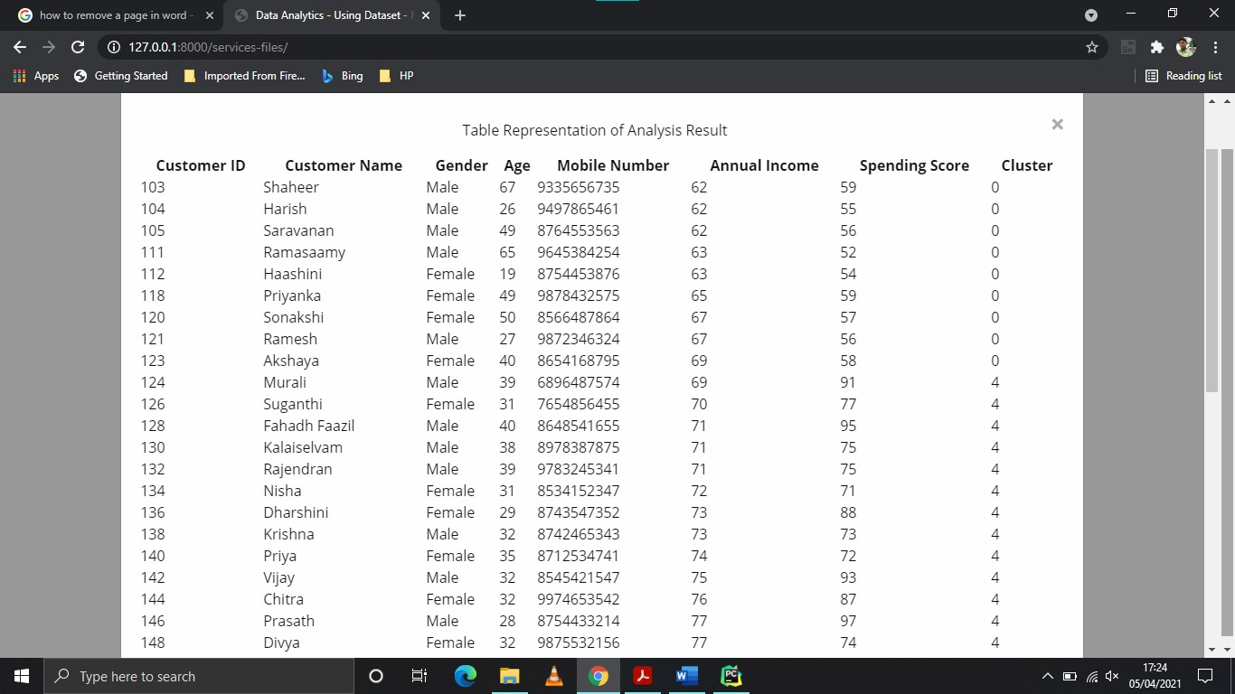

43

**Figure A7 – Analytics - Details Page**

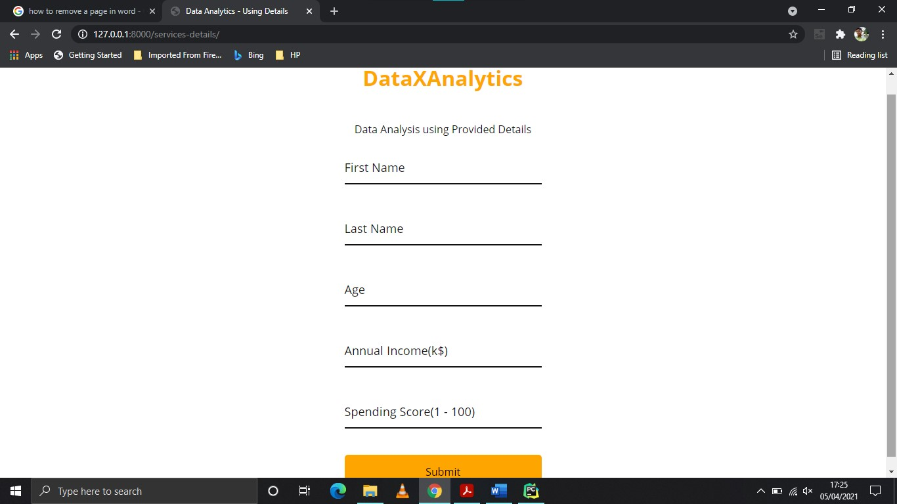

**Figure A8 – Analytics - Details Results Page**

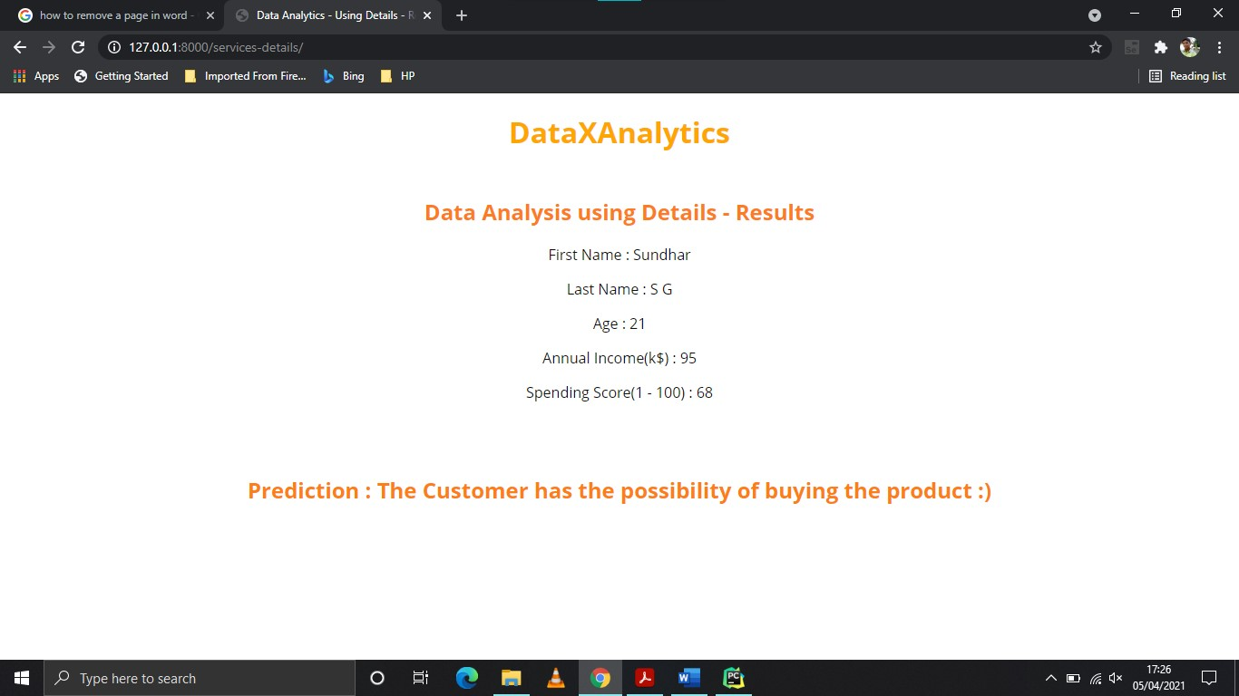

44

**REFERENCES**

**BOOK REFERENCES**

* Roger S.Pressman 2017, “**Software Engineering**”, Seventh Edition, Tata McGraw-Hill, Publishing Company Limited.
* Srinivasan Desikan, Gopalaswamy Ramesh 2017, “**Software Testing:**

**Principles and Practice**”, Seventh Edition, Prentice Hall.

* Mark Summerfield 2009, “**Programming in Python 3: A Complete Introduction to the Python Language**”, Second Edition, Pearson Education India.

# Antonio Mele 2020, “Django 3 By Example : Build powerful and reliable Python web applications”, Third Edition, Packt Publishing Limited.

# WEB REFERENCES

* https://www.javatpoint.com/python-django/
* https:/stackoverflow.com
* https://www.tutorialspoint.com/mysql/
* https://www.w3schools.com/

# 